**Cisco Packet Tracer Basic Commands**

**Roll Number:** 2420030009

**Submitted by:** Vudatha DhruvaSai

**Step-by-Step Configuration**

**Step 1: Set Up Your Network**

1. **Open Cisco Packet Tracer** and create a new workspace.
2. **Add Devices**:
   * Drag and drop a 3560 switch and at least two PCs into the workspace.
   * Connect the PCs to the switch using copper straight-through cables.

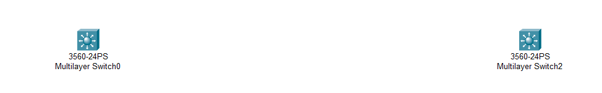

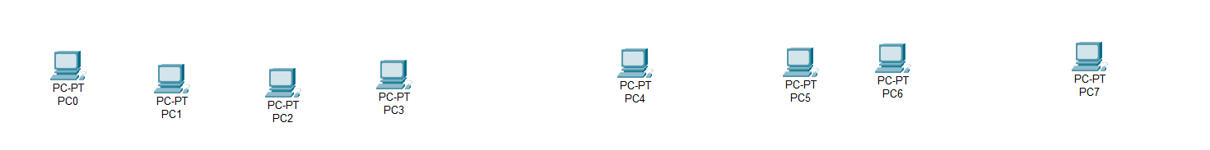

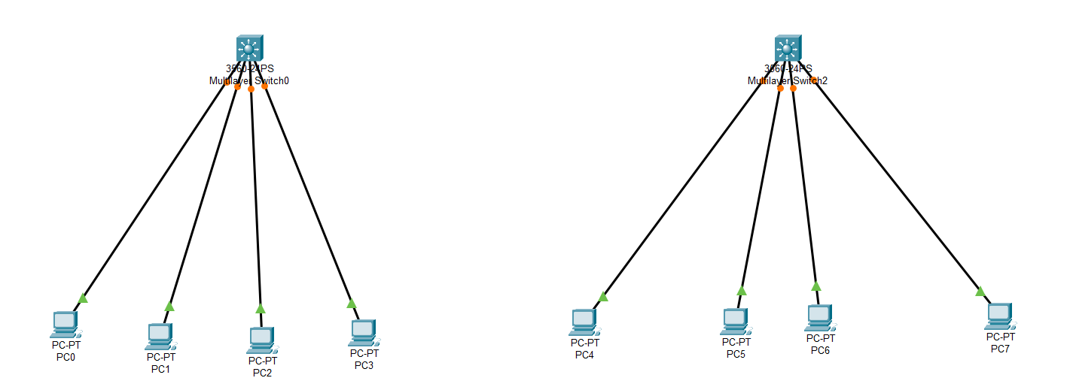

**Step 2: Configure VLANs on the Switch**

1. **Access the Switch CLI**:
   * Click on the switch.
   * Go to the CLI tab.
2. **Enter Global Configuration Mode**:

enable

configure terminal

1. **Create VLANs**:

# Create VLANs  
Switch(config)# vlan 10  
Switch(config-vlan)# name sales  
Switch(config-vlan)# exit  
  
Switch(config)# vlan 20  
Switch(config-vlan)# name product  
Switch(config-vlan)# exit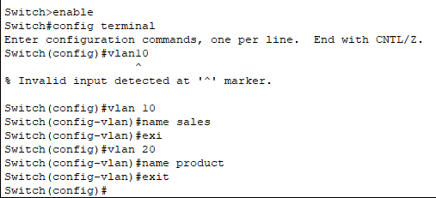

1. **Assign Ports to VLANs**:

# Assign ports to VLAN 10  
Switch(config)# interface range fa0/1 - 2  
Switch(config-if-range)# switchport mode access  
Switch(config-if-range)# switchport access vlan 10  
Switch(config-if-range)# exit  
  
# Assign ports to VLAN 20  
Switch(config)# interface range fa0/4 - 6  
Switch(config-if-range)# switchport mode access  
Switch(config-if-range)# switchport access vlan 20  
Switch(config-if-range)# exit

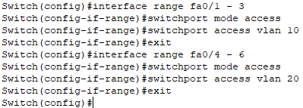

**Step 3: Configure Trunk Port on the Switch**

1. **Configure Trunk on the Switch**:

interface FastEthernet0/3

switchport trunk encapsulation dot1q

switchport mode trunk

exit

interface FastEthernet0/4

switchport trunk encapsulation dot1q

switchport mode trunk

exit

**Step 5: Verify Configuration**

1. **Check VLANs on the Switch**:

show vlan brief

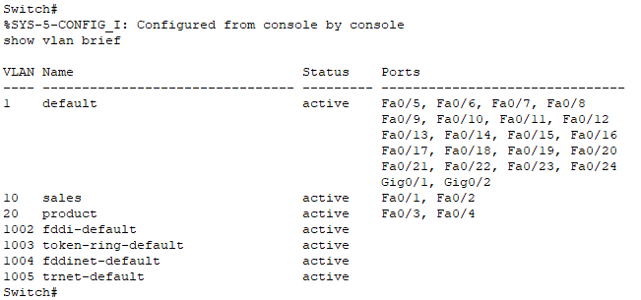

1. **Check Trunk Ports**:

show interfaces trunk

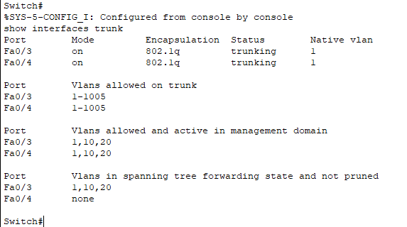

1. **Test Connectivity**:
   * Go to the command prompt on PC1 and ping PC2 to ensure they can communicate if routing is correctly set up.

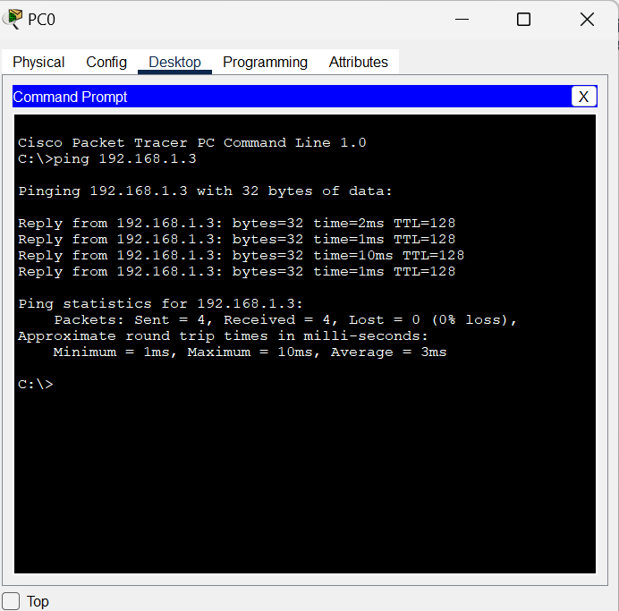

**Below is the project file**

